**Adding the secrete Scopes into Databricks through CLI**

**Getting the help in databricks CLI**

databricks secrets -h

**Listing the existing scopes in the DBX profile**

databricks secrets list-scopes --profile ngoct-uat-eu

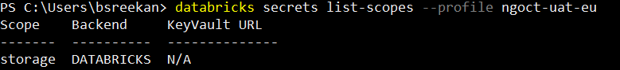

**Command to create a DBX profile (this is useful when managing multiple DBX accounts from same CLI)**

databricks configure -t --profile octeuprod

the above command will create a profile for PROD DBX, need to pass the User token as Token to create the profile for this



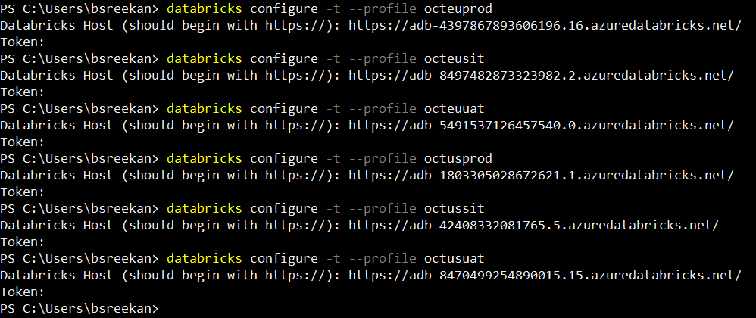

**Command to list the existing scopes in the DBX**

databricks secrets list-scopes --profile octeuuat

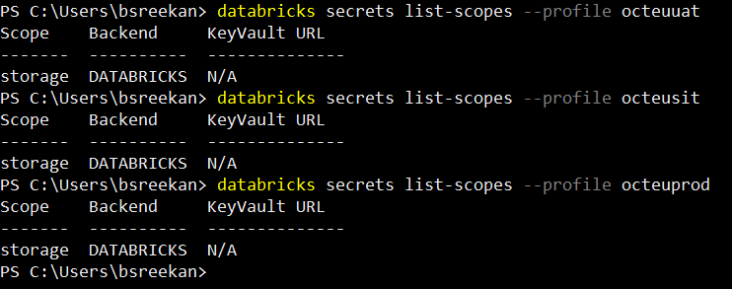

**Below command gives the key inside the scope storage**

databricks secrets list --scope storage --profile octeusit

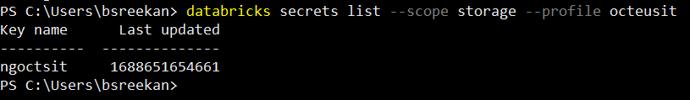

**Adding the new Secrete key for the DBX**

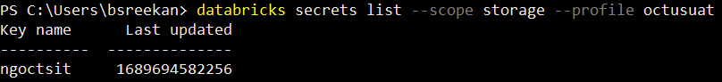

In above we see that the DBX is having only one Secrete key ngoctsit

After running the below command

databricks secrets put --key ngoctuat --scope storage --profile octusuat

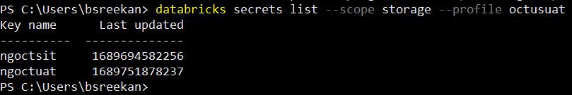

To change the key for the same secrete, run the same command then the Notepad will open, where we need to place the secrete for the scope